August 19, 2015
Dear Parents and Guardians,
In an effort to promote consistency in our Resource Rooms we have developed a behavior management system that will be in place in our classrooms. The following outlines our expectations:
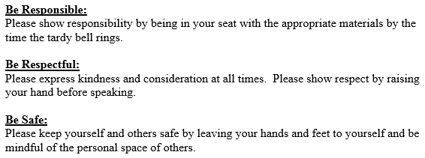
Students will be positively rewarded for following rules with tickets that they can spend in our classroom stores.
The consequences for not following classroom rules will be as follows:
- First offense: Firm Verbal Warning
- Second offense: 1-2 minute hallway conference with teacher
- Third offense: Phone call home, lunch detention, signed contract
- Fourth offense: Phone call home, AM detention

Sincerely,
The Middle School Resource Room Intervention Specialists
Jill Saracina, jsaracina@ofcs.net, 427-6284
Stacie Ware, sware@ofcs.net, 427-6218
Jessa Diaz, jdiaz@ofcs.net, 427-6316
Rachael Papa, rpapa@ofcs.net, 427-6228
Rachel Thomas, rthomas2@ofcs.net, 427-6265

Please sign and return the bottom portion to your Language Arts Teacher (Miss Diaz or Mrs. Thomas) by Wednesday, August 26.
I have read the classroom rules and expectations as outlined by the Resource Room teachers.

__________________________________(parent signature) ____________________(date)

