Read Outloud
The first, easiest thing you can do with Read Outloud is use it as a search engine. Anything on the internet can be read to the student.
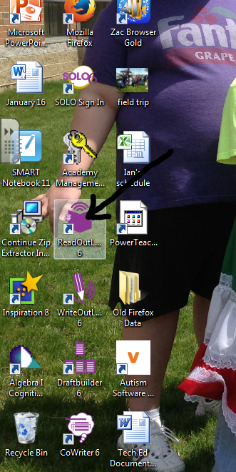
STEPS FOR READ OUTLOUD AS A SEARCH ENGINE
- Open Read Outloud

- Use the search engine to type in the website or topic you are looking for (just like you would on Google).
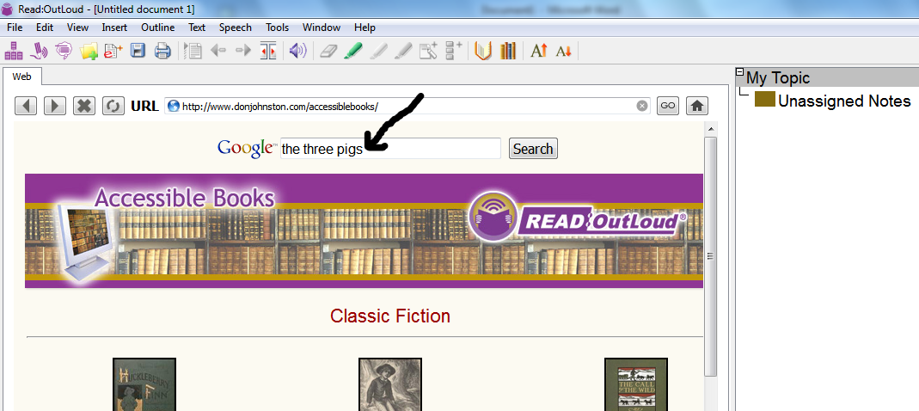

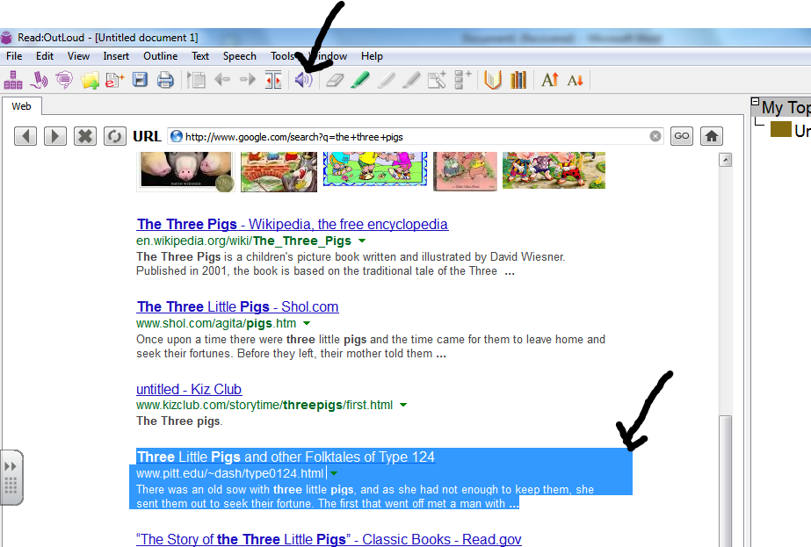
- Highlight what you want read and click the speaker button.

Read Outloud
The second thing you can do is use Read Outloud to read a Microsoft word file.
STEPS FOR READ OUTLOUD TO READ A MICROSOFT WORD FILE
- You must save your Word file as a RTF file.
  - Open the file you want in Microsoft word.

  - Click Save as
  - Click save as type: Rich Text Format
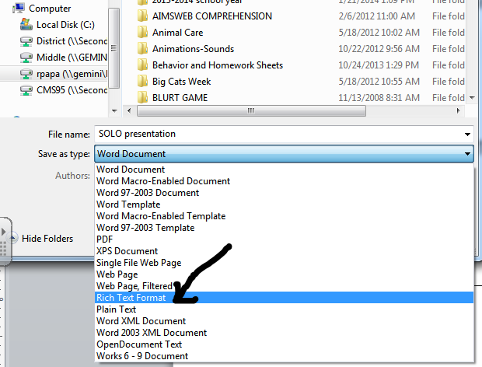

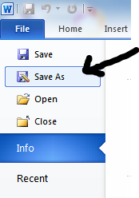

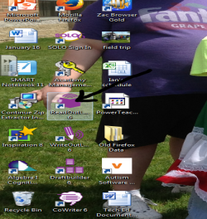
- Open Read Aloud

- Click Open and find your file. (You may have to click ALL FILES to find your file)

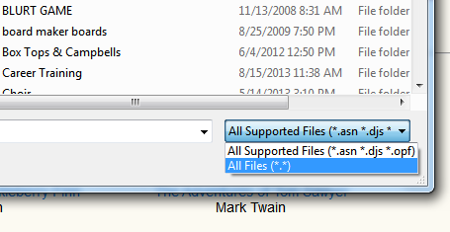

- Highlight text then click the speaker
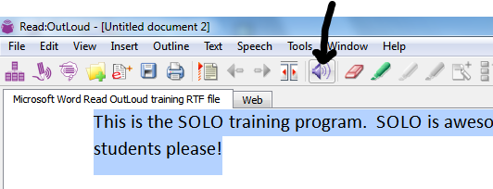

Read Outloud
Write questions in Read Outloud. Have the student find answers within the text and drag the answers to your questions.
STEPS FOR READ OUTLOUD AND ANSWERING QUESTIONS
- Open your file (see Microsoft Word or PDF instructions to do this). DON’T FORGET YOUR FILE MUST BE A READABLE PDF FILE OR A RTF FILE!!

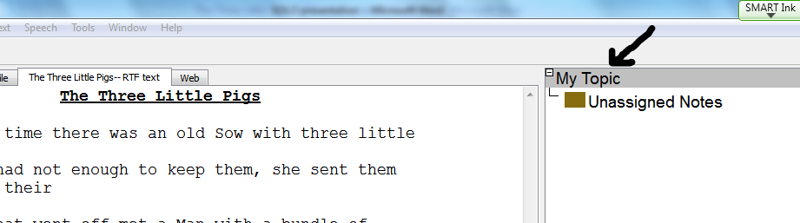
- On the right hand side, click “My Topic”

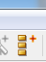
- On the toolbar, click
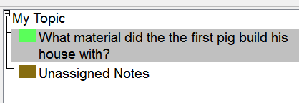
- A subtopic area will appear under “My Topic.” Type in your question

- The student can have the question read to him. He can then have the text read to him. When he hears the answer, he can stop the reading, highlight the answer and (on the toolbar) click the yellow highlighter.

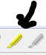

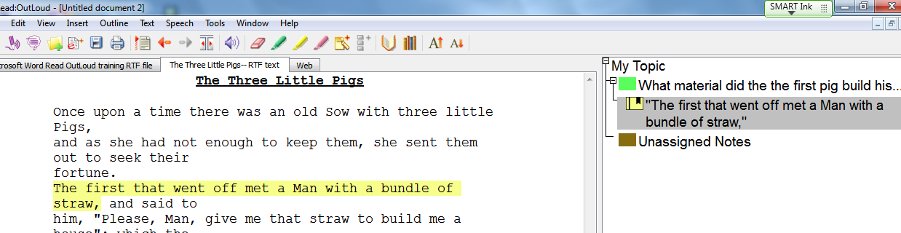

Read Outloud
Read Outloud can read PDF files or scanned files IF THEY ARE IN THE RIGHT FILE TYPE.
STEPS FOR READ OUTLOUD AND PDF FILES
- Open your PDF (or scanned file) as you would any other file in Read OutLoud. Read it as you would any other file. If it doesn’t work, you need to change the PDF to a PDF/A. Follow the directions below to do this.

- In order to change a PDF to a PDF/A, you need to use the ABBEY FINE READER program. Right now that is located only in Judy Casterline’s room.

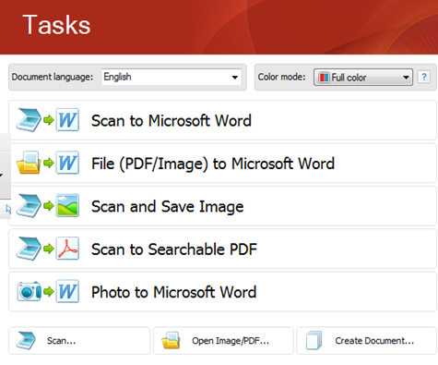
- Open Abbey Fine Reader

- Click Open Image/PDF
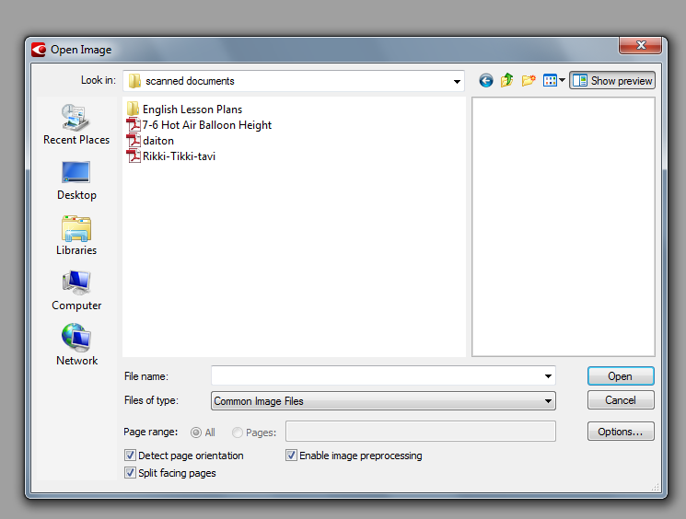
- Find and open your PDF.

- Wait for the program to scanning.
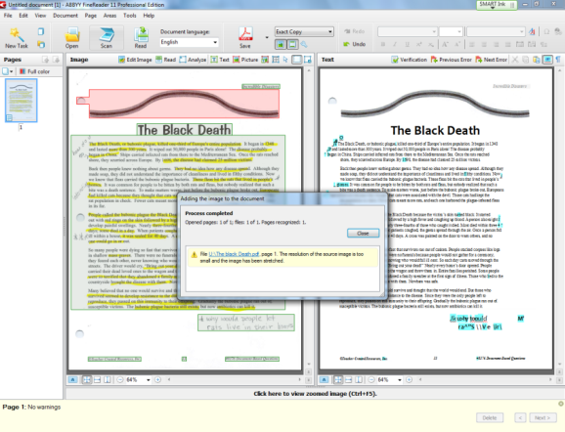

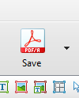
7. Click the Save As Icon. A drop down box will appear. CLICK SAVE AS PDF/A.
Hint: I save my file as the same name with Abbey after it so that I can recognize it easily.

8. Open in Read Outloud as you would any other file.
Write Outloud and CoWriter
With Write Outloud a student can type an assignment where the words and sentences are read back to him or her. CoWriter assists the student with spelling.
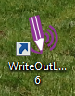
STEPS FOR WRITE OUTLOUD
- Open Write Outloud
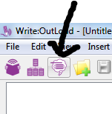
- Click CoWriter button if spelling assistance is needed.

- As the student types, words come up on CoWriter. If the student scrolls over the words, it reads the words to them. They can click what they want.

Hint: You can stop the program from reading each word by clicking the speech button on the toolbar and turning it off.
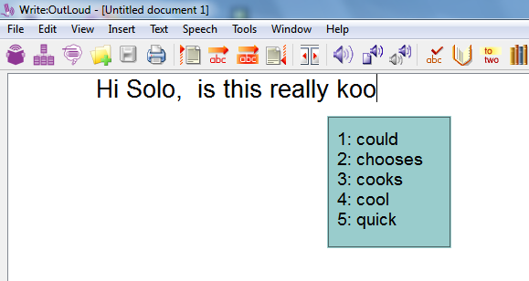

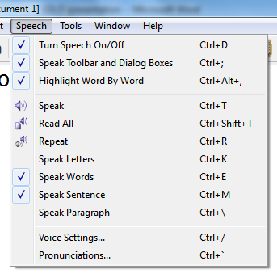
- If you have a worksheet you’d like a student to complete.

Write Outloud and CoWriter
If you have a worksheet you’d like a student to complete, you can open it in Write Outloud and have the type in the answers.
STEPS FOR OPENING A WORKSHEET ON WRITE OUTLOUD
- Save your worksheet as a RTF file.
HINT: Do not put underscores in (_____) for blanks as answers. The program will read this by continually saying underscore, underscore, etc.

- Open Write Outloud
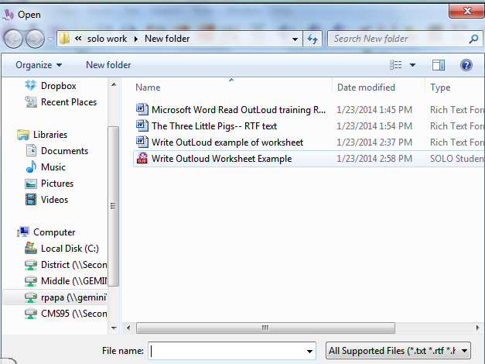

- Click File; Open. Then find your file.

- The student can then write their answers in. Remember, they can use Co-Writer to help with spelling, but you must open it!

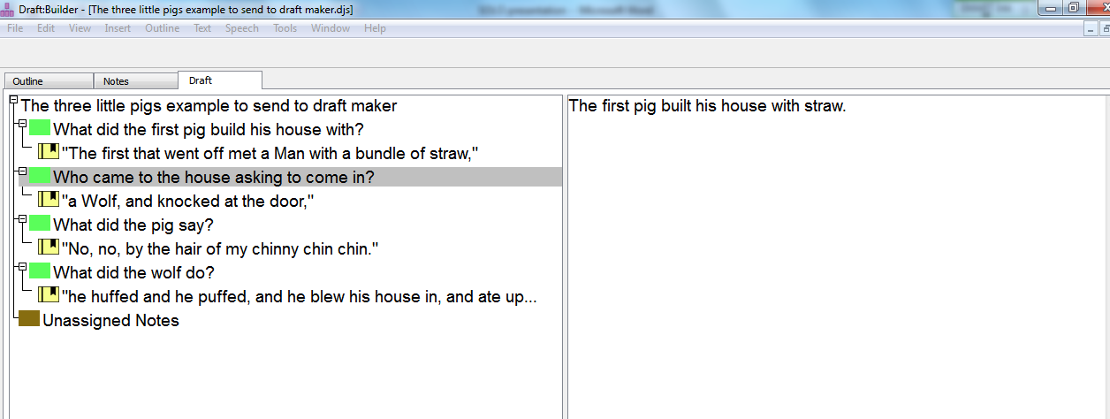
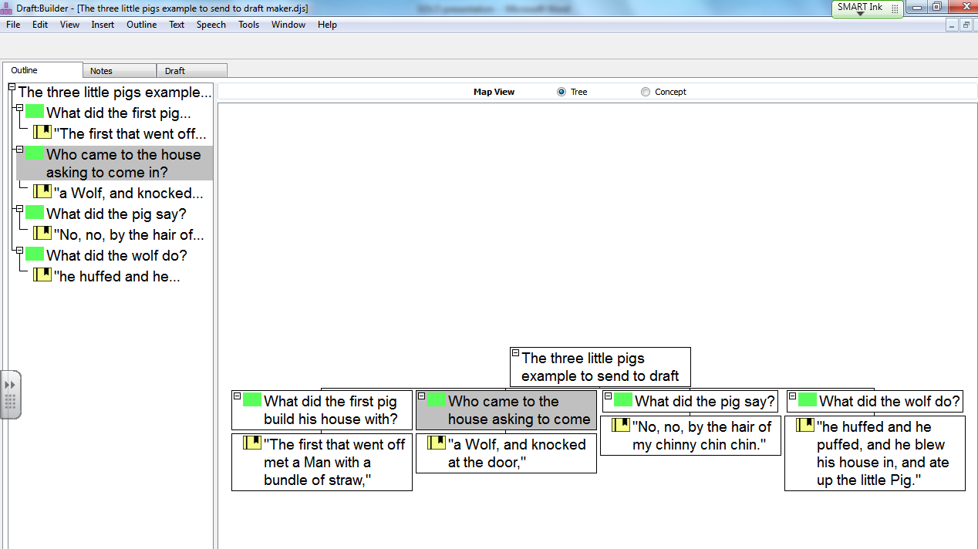
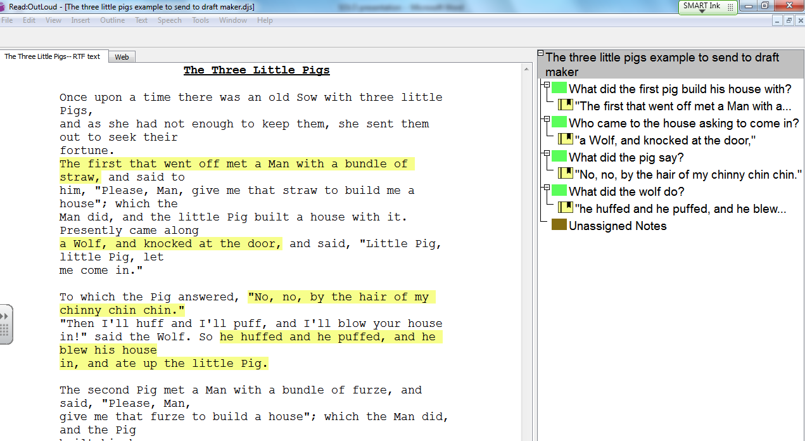
Draft Builder---- You can do a lot with this program and I am still experimenting if you want to learn this please see me at another time. Below are pictures of things you can do with it:
- Student can answer premade questions (or information they found from text in Read Outloud) to draft builder to help make concept maps before writing. They can then use these drafts to write a summary in the program.
CoWriter
You can use Co-Writer to help with spelling in any program on the entire computer. The teacher can set up Co-Writer to be topic specific if they want.
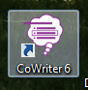
USING COWRITER AS TOPIC SPECIFIC
- Open CoWriter

- Click the arrow on the bottom right side of Co-Writer.
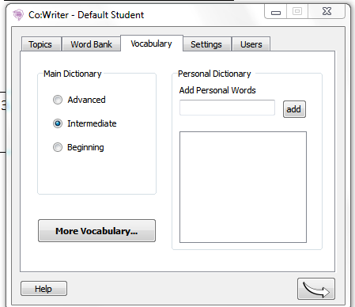
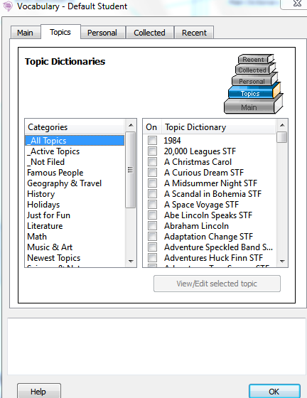
- Click Arrow to exit.
- Chose topic.
- Click Vocabulary; More Vocabulary.

